Employees’
Mini-Help Guide

Contents
Overview 2
Getting Started 2
Logging In 2
System Overview 3
Dashboard 7
Timesheets 8
Timesheet Status 8
Submitting Timesheets 8
Managing Multiple Jobs 8
Entering Hours on a Timesheet 9
Submitting Timesheets 11
Missing Timesheets 12
Resetting a Timesheet 13
Automated Reminders 13
Expenses 14
Profile 5

Overview
astutepayroll.com is web based software that assists recruitment firms to manage the administration of their on-hire and contracting businesses.
If you are reading this Mini-Help Guide: you are likely to be working through a recruitment firm on a temporary or contract basis and will be required to submit Timesheets for the hours/days you work.
The function of “Employee” on the system manages both employees of the recruitment firm (PAYG) and employees of another entity (ABN Subcontractor) who are working through the recruitment firm.
As an Employee, the system is a key interface that enables you to manage the administrative tasks required of you by both the recruitment firm and the Approver at your workplace.
This Mini-Help Guide is designed to give Employees a quick overview of the key functions on the system. For more details please refer to the relevant full Help Guide.

Getting Started
The recruitment firm will set up access for you on the system. This will automatically send you an email with your login details. If you have not received this email please contact the recruitment firm.
The new user email will provide you with your username and password. It will also direct you to the relevant URL to login.

Logging In
- You will see a login screen that looks like this image.
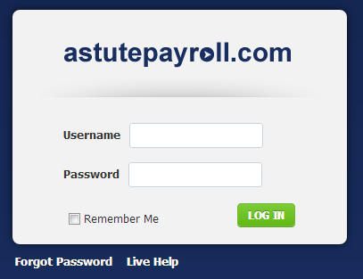
  - If you forget your Username or Password, select ‘Forgot password’.
  - You can then enter your username or email address and your details will be sent to your registered email address.
- When logging in you may be presented with Terms and Conditions that you need to review and acknowledge.
- Once logged in, you can change your password in the profile section. You are not able to change your username.

System Overview
The Employee System supports the following functions:
Menu | Description | Location of Function
Compliance | Enables you to sign off on all documentation – such as employment agreements. | Compliance Documents will be presented to you when you login. You must agree to the terms before you will be able to proceed into the system.  If you disagree with any terms, you will need to speak with the recruitment firm.  You can view all compliance documents that you have signed in the Profile Tab.
Induction | Enables you to provide your personal and banking details so that you can get paid. | Managed through the Profile Tab  If any information is missing you will be taken to this section when you login and missing information will be highlighted.
Employee Self-Service | Enables you to update your details on an ongoing basis, to review information about your job(s), and to access documents and news from the recruitment firm. | Range of places on the system:  Dashboard: News; Downloads  Profile Tab: personal/banking details; job history  Timesheet Tab: historic Timesheets
Timesheets | Enables you to submit Timesheets for approval and payment. | On the Dashboard: click on “Log Time” or the relevant Timesheet in the Timesheet Summary  You c an also access all Timesheets, including future and archived Timesheets, via the Timesheet Tab
Expenses | Enables you to submit Expense reports with attached receipts. NOTE: this function will only be available if the job you are on allows/requires you to submit Expenses. | On the Dashboard: click on “Log Expense” or the relevant Expense in the Expense Summary  You can also access all Expenses via the Expenses Tab

Compliance
When logging into the portal for the first time, you may be presented with Terms & Agreement for your Employment that must be read and accepted before you enter your timesheets.
From time to time, your Employer may add new documents that you need to read and accept, these may be things such as an updated policy or procdure, or a company notice that needs to be acknowledged.
Unless these documents are signed off, you will not be able to proceed any further into the portal. If you have any queries relating directly to your documents, please contact your Recruitment Agency directly to discuss.
If you have trouble viewing the file or would like to keep a copy for your records, you can download it by clicking on it’s corresponding link in the document title.
To acknowledge that you have read and accepted the document/s, tick the checkbox underneath each of the documents. When you get to the bottom of the page, click “Agree”.
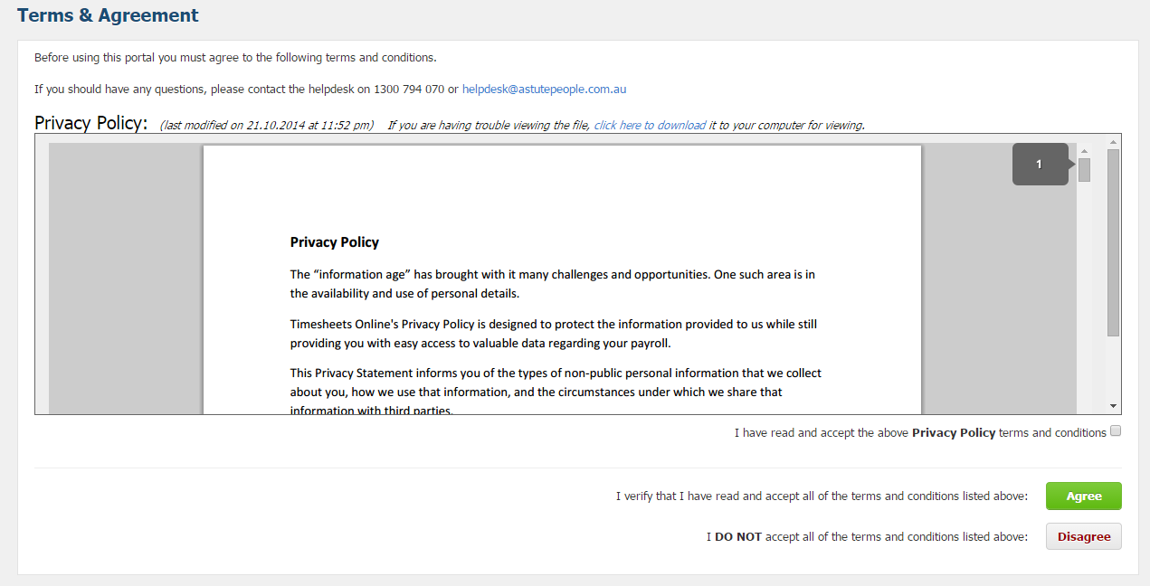

Profile
The Profile Tab is the section where your personal and employment details are kept. When you first log in, you will be taken to your Profile page if there is any outstanding data to be completed. Please complete all fields that are flagged to help ensure your profile is complete and you can be paid correctly.
For ease of reference, your profile is separated into the following Tabs:
Menu | Description
Personal details | Name, birth date, address and contact details as well as Emergency Contact information.
Password | You can change your password from here.
Employment details | Details your employment status with your recruitment firm, eg PAYG or subcontractor.
Bank accounts | Please ensure your account details are correct to receive your salary.
Tax and super | Enter your Tax details and details of your superannuation fund.
Payslips | Displays your payslips for you to download.  Note: if your recruitment company is using an external payroll program (e.g. MYOB), your payslips may not display here.
Compliance docs | Details any compliance documentation which you have read and acknowledged.
Active Jobs | Lists each of your active jobs and provides details, including:  - Start/finish dates  - Pay rates  - Designated Approvers; and  - Timesheets and Expenses submitted.
Inactive Jobs | Lists each of your inactive (previous or future) jobs and provides details, including:  - Start/finish dates  - Pay rates  - Designated Approvers; and  - Timesheets and Expenses submitted.

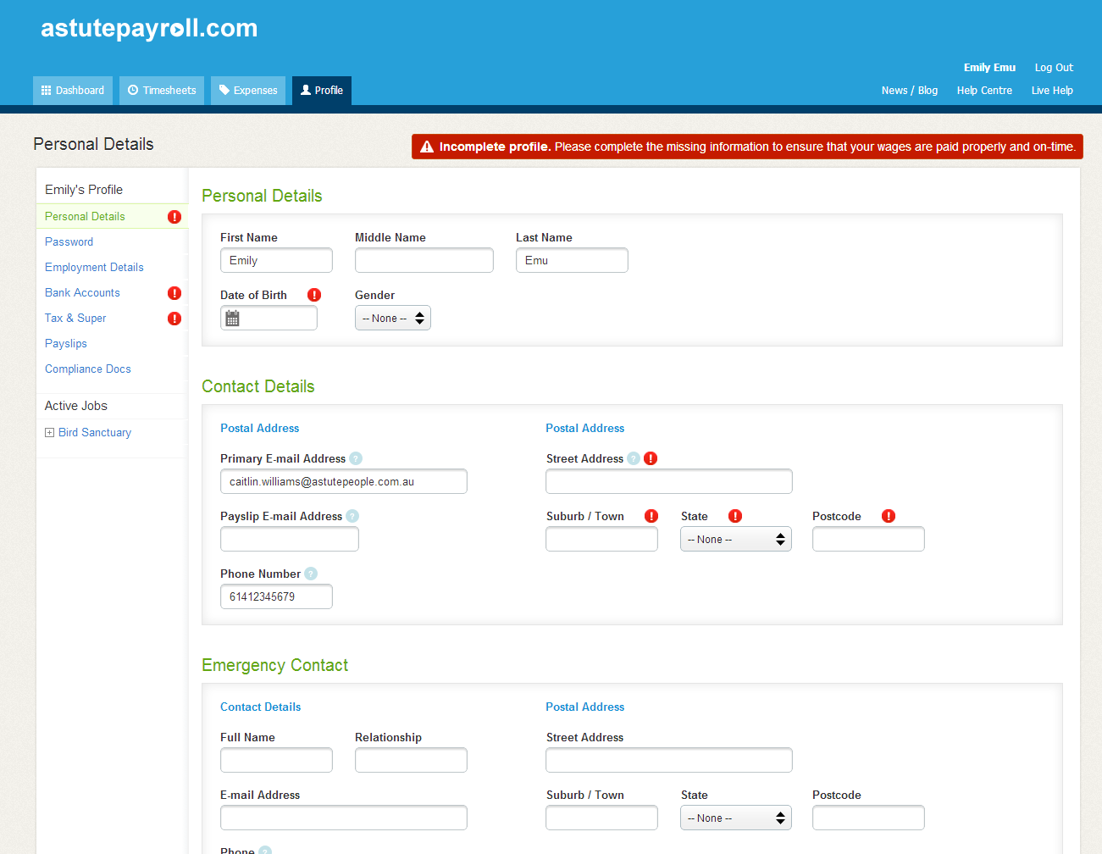

Dashboard
The Dashboard is the home page of the system, and provides a snapshot of what is happening on the system and a way to quickly access commonly used tasks.
The table below describes the functions of the Dashboard.
Function | Description
Timesheet Summary | Provides a summary of recent Timesheet activity.  Click on the link to be taken to the relevant Timesheet.
Expenses Summary | Provides a summary of recent Expenses activity.  Click on the link to be taken to the relevant Expense.
Your Profile | Displays the more commonly used functions in your profile – click on a function to view or edit these details.
News | Displays notices and news items.  This is designed to be a regularly updated snapshot of your firm’s news.
Downloads | This is a document library compiled by your recruitment firm for your reference.

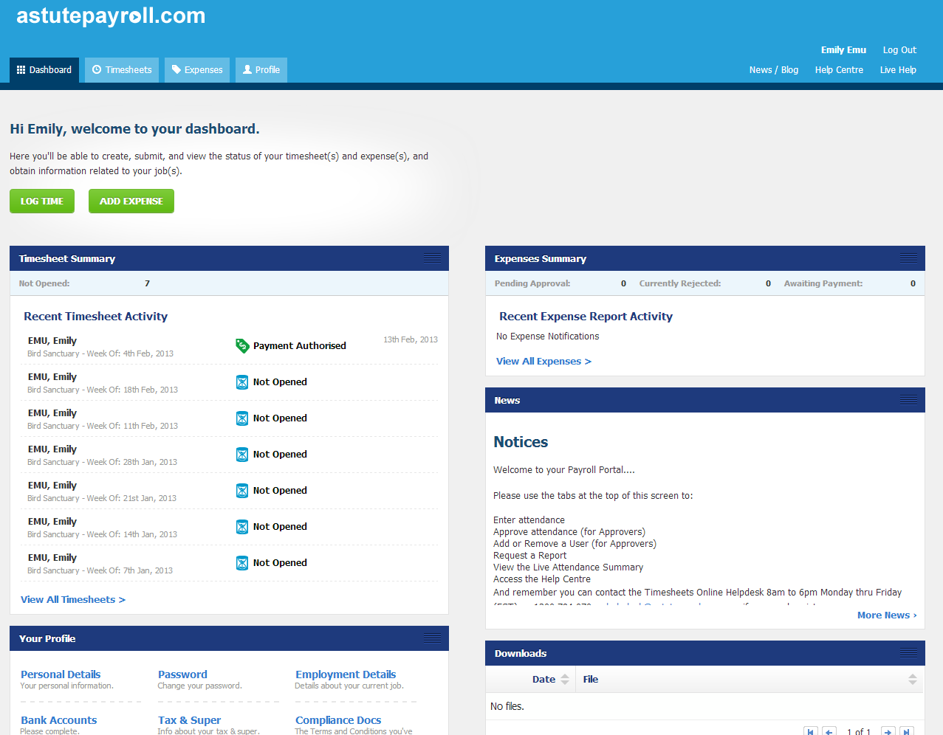

Timesheets
You will be required to submit Timesheets on a frequency set by your recruitment firm.
Typically this will be a “Sunday to Saturday” Timesheet with a submission deadline of 9am Monday morning.

Timesheet Status
Function | Description | Action Required
Not Opened | You have yet to enter any information into the Timesheet | Fill in and submit your Timesheet by the deadline
Pending Submission | You have yet to submit the Timesheet for approval | Fill in and submit your Timesheet by the deadline
Pending Approval | Your submitted Timesheet is awaiting approval | Follow up with your Approver to ensure the Timesheet is approved on time
Rejected | Your Timesheet has been queried and not approved | Review reason provided for rejection, update Timesheet and resubmit
Ready for Interpretation | Your Timesheet has been approved and is awaiting payroll processing | No action required
Payment Authorised | Your Timesheet has been processed through payroll and is ready to be paid | No action required

Submitting Timesheets
There are three ways in which you can submit Timesheets on the system:
- Dashboard: click on “Log Time”
- Dashboard: click on the relevant Timesheet in the Timesheet Summary
- Timesheets Tab: provides you with access to all Timesheets, including future and archived Timesheets.

Managing Multiple Jobs
If you are working multiple jobs concurrently in a timesheet period, you have the option to submit one timesheet containing all hours for all jobs. You will also have the option to access the individual job timesheets via the “Available Jobs in Timesheet” menu on the right hand side of the timesheet. See the following screenshot for further directions.
Please note: if you are working in only one job within a timesheet period, you will only be able to submit hours for that job on the timesheet.

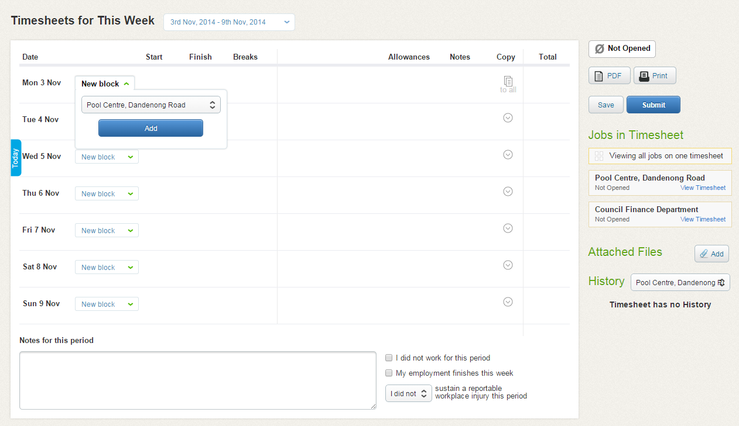
Click “View Timesheet” for individual job to enter hours and submit without Timesheet Overlay
Click “New Block” to select Job, Project and/or Pay Item
Click “Save” or “Submit” to save the entire overlay timesheet
Click the Job from the drop down menu to view the individual timesheet history

Entering Hours on a Timesheet
When you open a timesheet, you will note that each day offers the ability to add a new ‘Time Block’. A time block allows you to allocate your hours worked against specific jobs, pay rates or projects.
For example, you could allocate a time block of 9am – 12pm to a specific job, against a specific project and at a specific pay rate. Then you could allocate another time block of 12pm – 5pm against a different job, project and pay rate.
Click on ‘New Time Block’ against a day and depending on how your job profile is configured, you will have several options to choose from.
- Job: if you are working in multiple jobs, you will be able to select the relevant job from this drop down list.
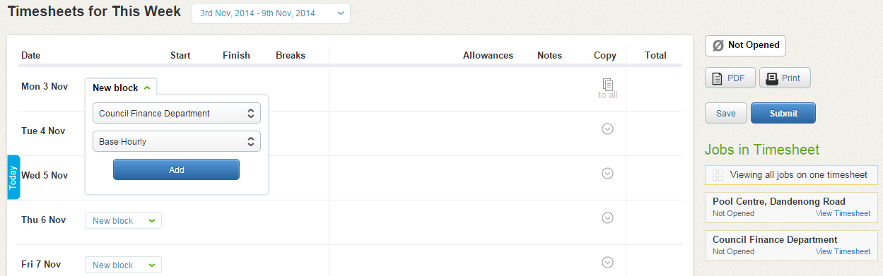
Select the relevant job (if you have multiple jobs in the one period).

- Project: If projects are enabled on your job, you will be able to select a project component from this list.
Select the relevant job (if you have multiple jobs in the one period).

- Pay Item: If multiple pay items are assigned to your job, you will be able to select the pay item you should be paid against for the time block. The default is ‘Base Pay’. If you are entitled to overtime (e.g. OTx1.5) or a shift allowance (e.g. Night Shift), this will also appear in this drop down and you can allocate your hours against it accordingly.
Note: your recruitment company may choose to manage overtime and shift rates separately to the timesheet, therefore they will not appear for you in the timesheet. Please discuss this with your recruitment company.
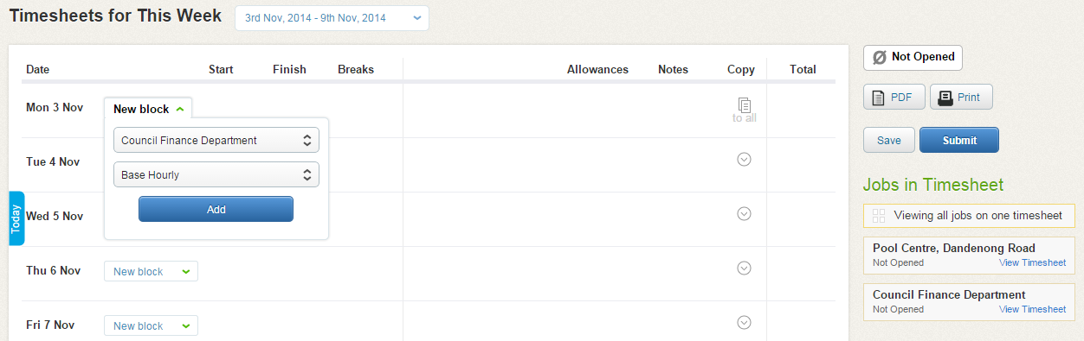
Select the relevant Pay Item attached with the time block e.g. if it’s OT x 1.5 select “OT x 1.5” from the drop down list.
Once you have selected the job, project and pay item, press ‘Add’. This will save the time block within the timesheet and allow you to enter further information.
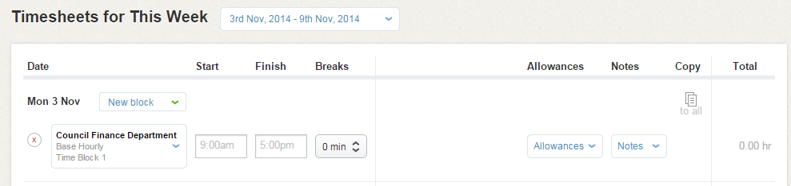

You now have the option to add:
- Start time (e.g. 9:00am)
- Finish time (e.g. 5:00pm)
- Breaks (e.g. 45 minutes)
- Leave (if assigned to you – select the category and then applicable time taken)
- Allowances (if assigned to you – select the allowance type)
- Notes (any notes you need your recruiter or approver to see)
You can also press ‘Copy Down’ which copies all of the information from that Time Block onto the other days of the week.
If you need to add more time to the same day, you can press ‘New Time Block’ and enter in information for that time block. Otherwise, you can add in time blocks for the rest of the week.

Adding Timesheet Attachments
You can add attachments to a timesheet (manual timesheet or km’s form etc) by clicking on the Attached Files “Add” button.

Submitting Timesheets
Submitting a timesheet is very simple.
If you haven’t worked for that week, rather than not submitting the timesheet, you can tick the “I did not work for this period” check box. This will prevent any further timesheet reminders being sent to your email address.
You can also advise your Recruiter/Agency via the timesheet if your employment finishes by ticking the “My employment finishes this week” check box.
Before submitting your timesheet, if you have sustained a reportable workplace injury for this period, you should notate this on your timesheet. The timesheet defaults to “I did not sustain a reportable injury this period”, however if you did sustain a reportable injury, select “I did” from the dropdown list. This should be completed in conjunction with any OH & S processes of your Agency.
If you have entered in hours on one timesheet for on job, pressing ‘Submit’ will send your timesheet to your approver via email to be approved.
If you have entered in hours on one timesheet for multiple jobs, pressing ‘Submit’ will bring up a list of the jobs contained on that timesheet. Select the jobs you would like to submit the timesheets for and press ‘Confirm’.
If you only submit one timesheet out of multiple, the remaining timesheets will be saved and retain a status of Pending Submission.
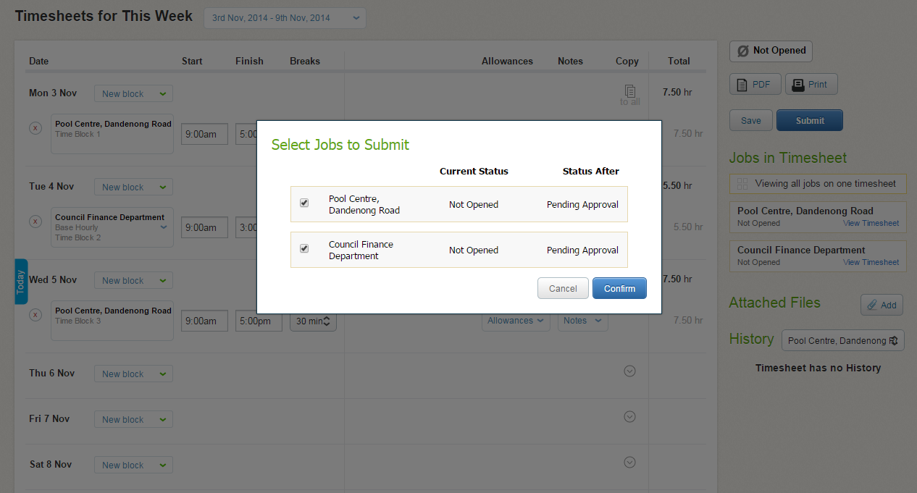

Missing Timesheets
If you are unable to see a Timesheet for your current week, it is likely that the finish date for your job has lapsed and Timesheets will no longer be presented.
Please contact your Recruiter to extend the finish date of your job.
Once a job has finished and all Timesheets completed, you will no longer be able to access active timesheets. You will still be able to access information and the Timesheet archive for the job in your Profile > Job Profiles > Inactive Jobs.

Resetting a Timesheet
Once you have submitted a Timesheet you will no longer be able to edit it.
If the Timesheet is Pending Approval you can ask your Approver to reject the Timesheet.
Once the Timesheet has been approved, it can only be reset by a Portal Administrator at the recruitment firm. Please contact your recruitment firm to arrange for this to happen.

Automated Reminders
You will receive the following emails reminders related to your Timesheets:
- Friday afternoon – First submission reminder: please remember to complete your Timesheet for the week. Needs to be submitted by 10am Monday morning.
- Monday 9am – Final submission reminder: if your Timesheet isn’t submitted by 10am you will miss payroll deadline and your pay may be delayed.
- Monday 12.30pm – Approval Reminder: your Approver will be reminded of any outstanding approvals
- Monday 12.30pm – Approval Reminder: you will be notified if your submitted Timesheet has not been approved (go and speak with your Approver)
- Timesheet Approved/Rejected: you will be notified
- If a Timesheet (requiring) has not been actioned by 12.30pm Monday, the Primary Approver will receive a system generated reminder. If a Primary Approver has not actioned a Timesheet by 2.00pm Monday, the Secondary Approver will receive a system generated reminder.
Once a Timesheet is approved, it will be ready for payroll. If a Timesheet is rejected, it will be returned to the contractor for correction and resubmission.
Automated reminders are not issued for Expenses.

Expenses
The Expenses tab is an optional feature that must be activated through your recruitment firm for it to appear as a menu option.
An Expense claim is very simple to complete and submit:
- Select ‘New Expense Report’ – a box will appear requesting a name for your Expense Report (eg January 2012)
- Insert the name for your Expense Report (eg July Expenses) and click Save
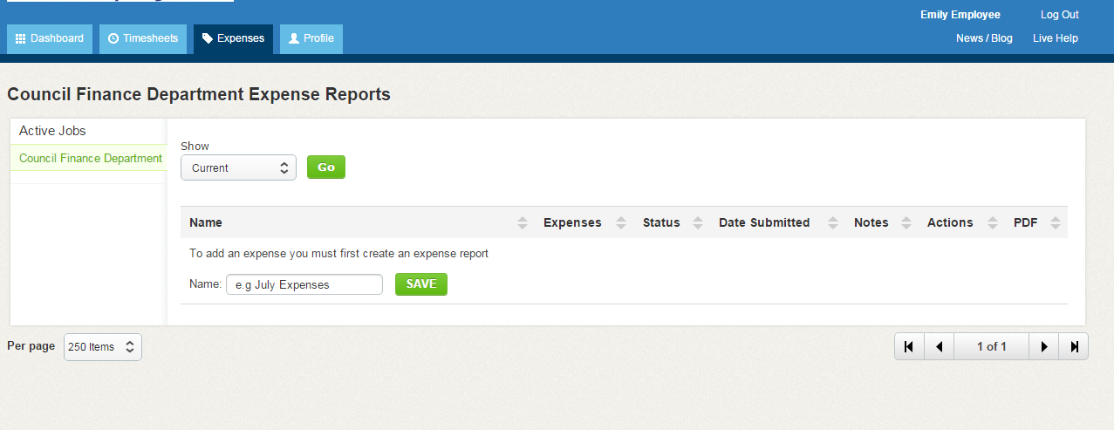
- Select the Expense Report name to open it and select ‘New Expense’ to add your Expenses.
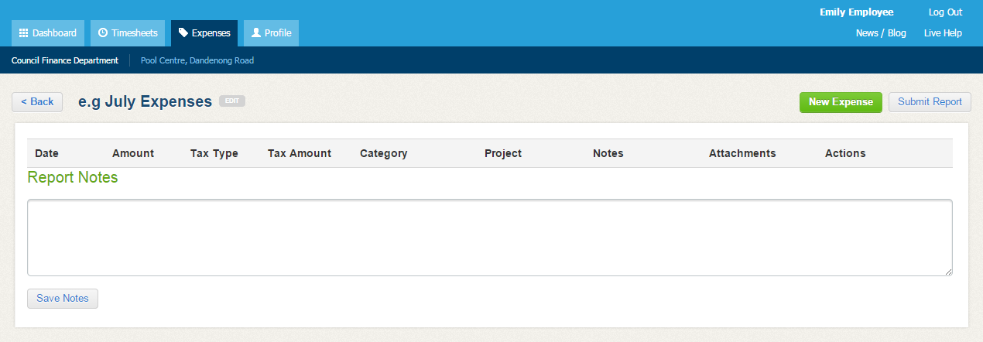
- Complete the details in each field and click ‘Save’. You can then:
- Attach a copy of your invoice or receipt
- Add additional Expenses by selecting ‘New Expense’ and click ‘Save’
- Click ‘<Back’ if your Expense Report is incomplete or you don’t yet wish to submit for approval
- Click ‘Submit Report’ to submit your Expense claim for approval.
- Add any notes relating to the expense claim.
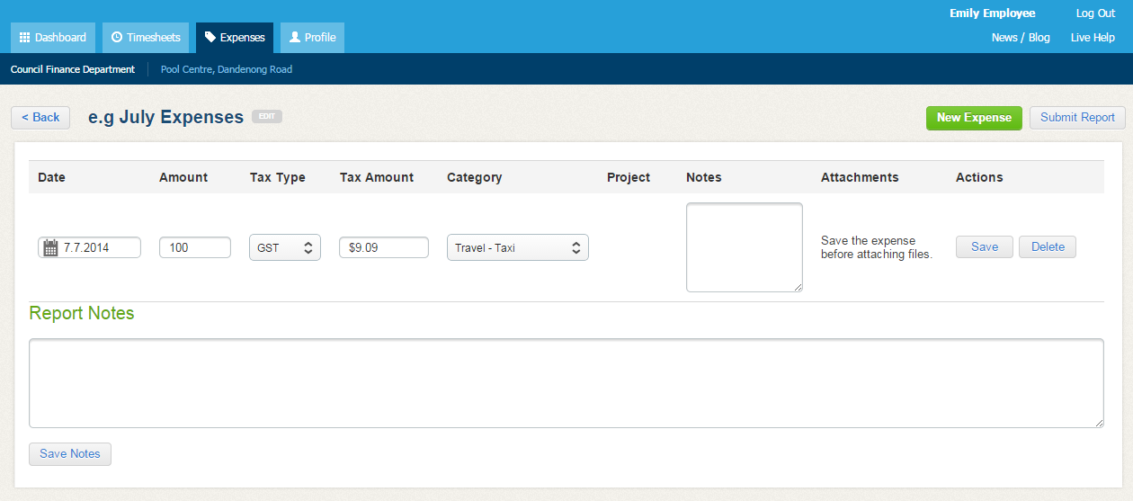
Once an Expense is approved, it will be ready for payroll. If an Expense is rejected, it will be returned to you for correction and resubmission.

